Human Health Service Sector Report

What is the Human Health Services Sector?

The human health services sector includes companies that specialise in the delivery of human services.

Analysis of the Turnover of the sector by NUTS1 Region from 2017-2021

Analysis of the total turnover for each NUTS1 region from 2017-2021 and it is clear to see that London dominates this metric with over half of the revenue generated in this region.
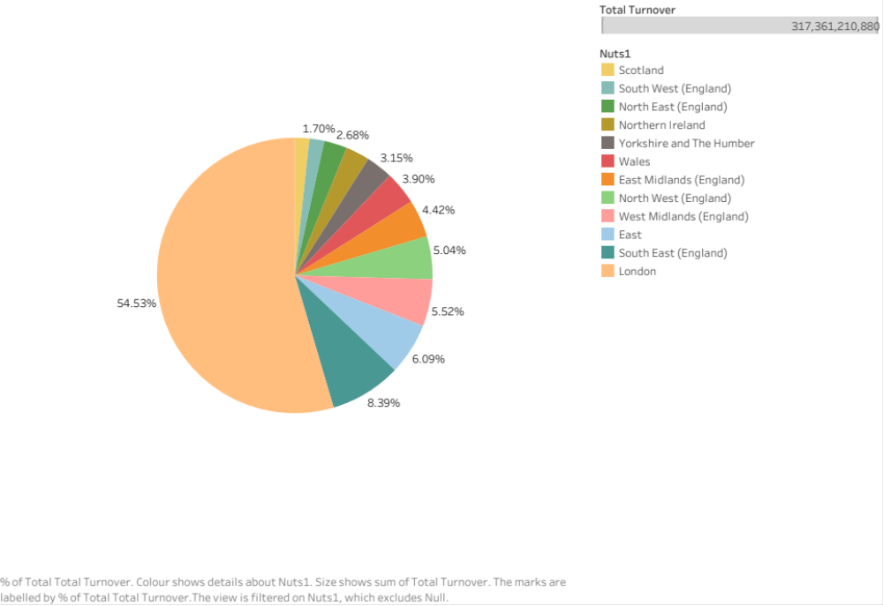

However, to see that this effect is not solely due to the sheer number of businesses present in this region, we investigated the turnover with respect to the number of businesses registered.

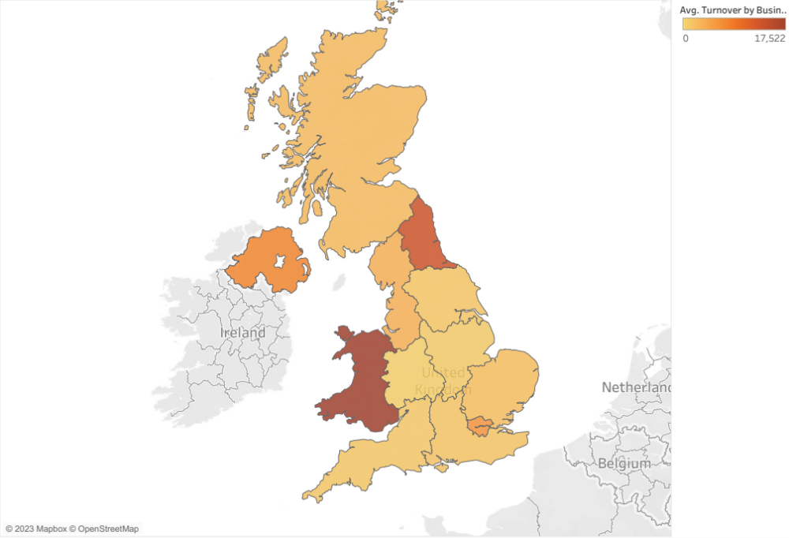
Geographical Map showing the yearly turnover per the number of businesses
For each NUTS1 region in 2021.

Wales generated the highest turnover with respect to the number of businesses at over £17,000 revenue per company on average followed by the North East at over £13,000.
Although the region of London may have the highest gross turnover, it has a mediocre turnover of just under £6,000 reflecting the high number of companies present.

Yearly turnover per the number of businesses for London and North East regions in 2021.
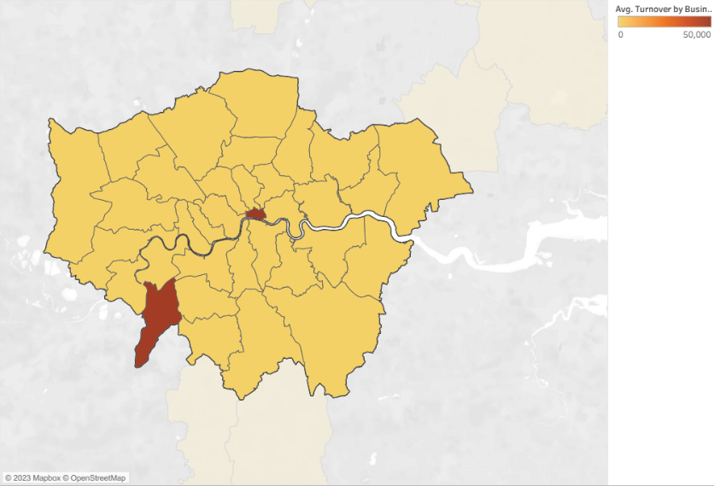

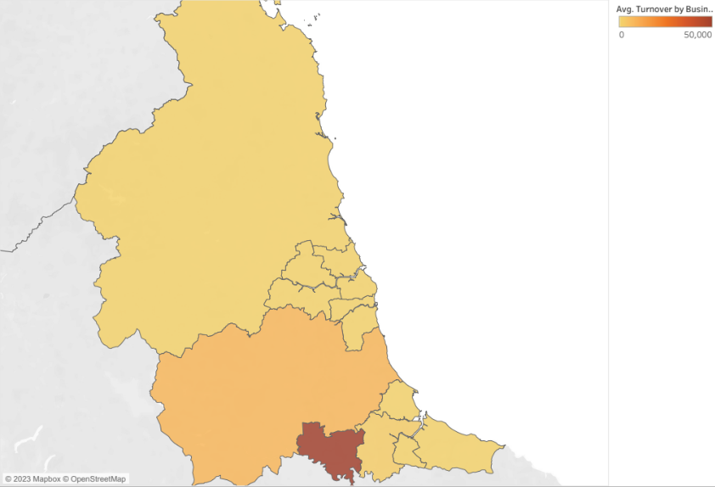

When we drill down and look at local authorities representing each NUTS1 region (London and North East in this case), we find that each region’s average turnover metric is dominated by 1-2 local authorities such as the City of London and Kingston upon Thames with £95,000 and approximately £50,000 respectively for the region of London. Similarly, for the North East, Darlington with a turnover of £120,000 per the number of businesses residing within that authority.

This trend is seen for the majority of NUTS1 regions in the UK for the years between 2017-2021, clearly reflecting the disparities in the economic output of this sector between local authorities.

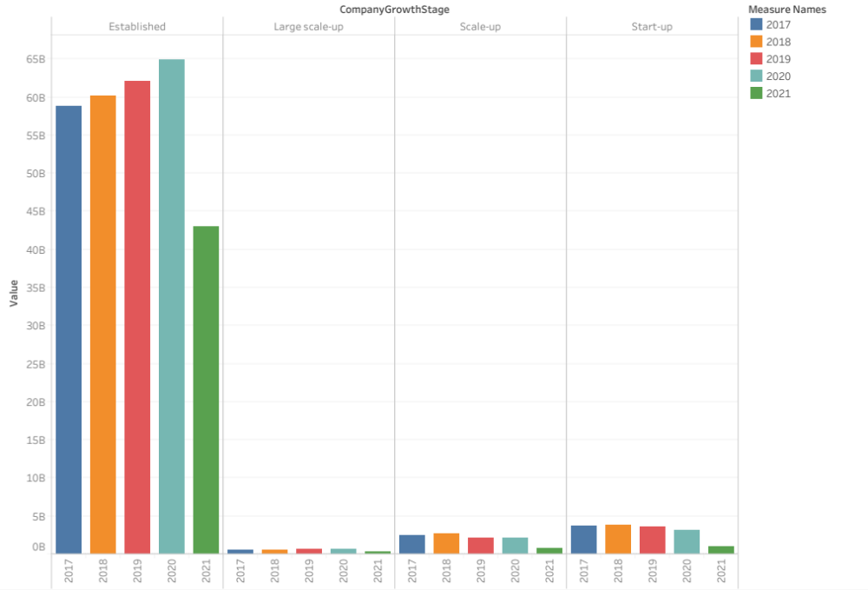
Yearly Turnover by company growth stage

In order to see what type of companies are contributing to the turnover, the bar graph shows that established companies contribute the majority of the total turnover (approx 90%) from 2017-2021.

For companies that are not established, there has been a gradual decreasing trend in the economic output from 2017-2020 before this exacerbated in 2021.

For established companies, yearly turnover saw an increase from 2017 with its peak at 2020 before a drastic drop off of around £25 billion in 2021.

Summary of the economic output of the human health services sector
- The turnover statistics show great disparities at the local geographical scale where a small number of large established companies contribute the overwhelming majority of the turnover.
- There has been a massive drop off in 2021 with £30 billion lost in total in this sector, probably due to the effects of the pandemic.

Analysis of the key financial indicators (KFI’s)

Total Yearly equity by company growth stage

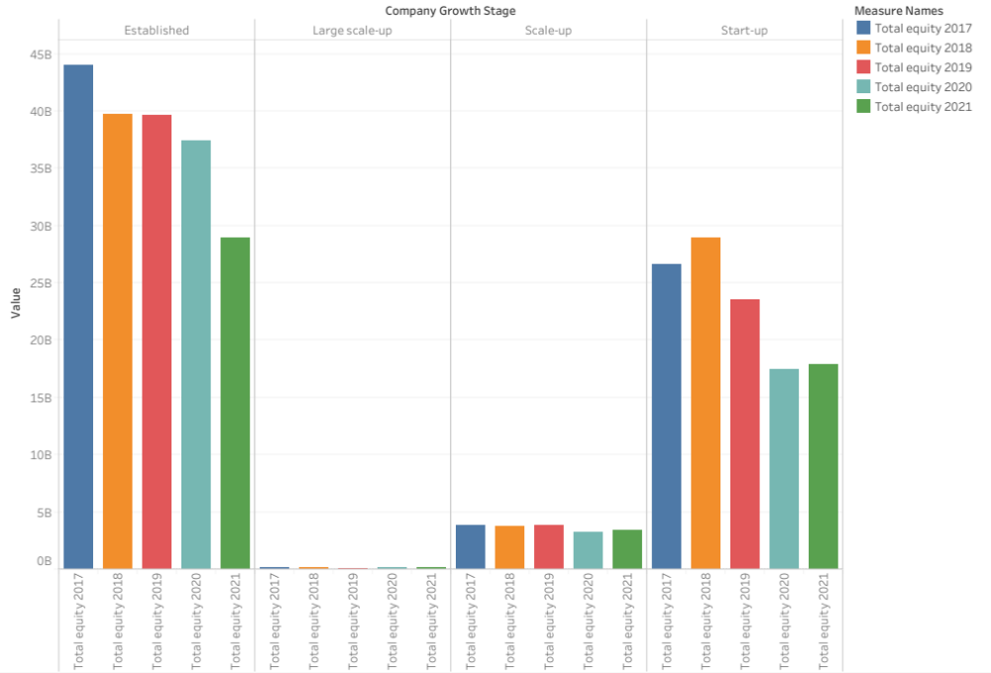

For established companies, the total yearly equity has been decreasing consistently but coupled with the increase in the turnover especially before 2021, this indicates increasing liabilities.
A similar trend has been occurring for the rest of the company growth types although it has not seen a drastic drop as the established companies. One could then conclude that smaller companies have seen decreasing assets but relatively stable liabilities.

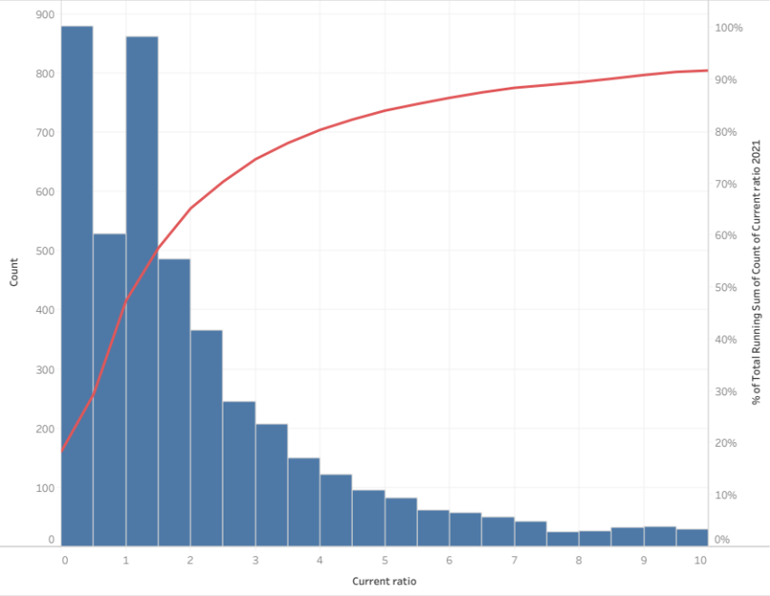
Histogram of the Current Ratio and the debt to equity ratio in 2021

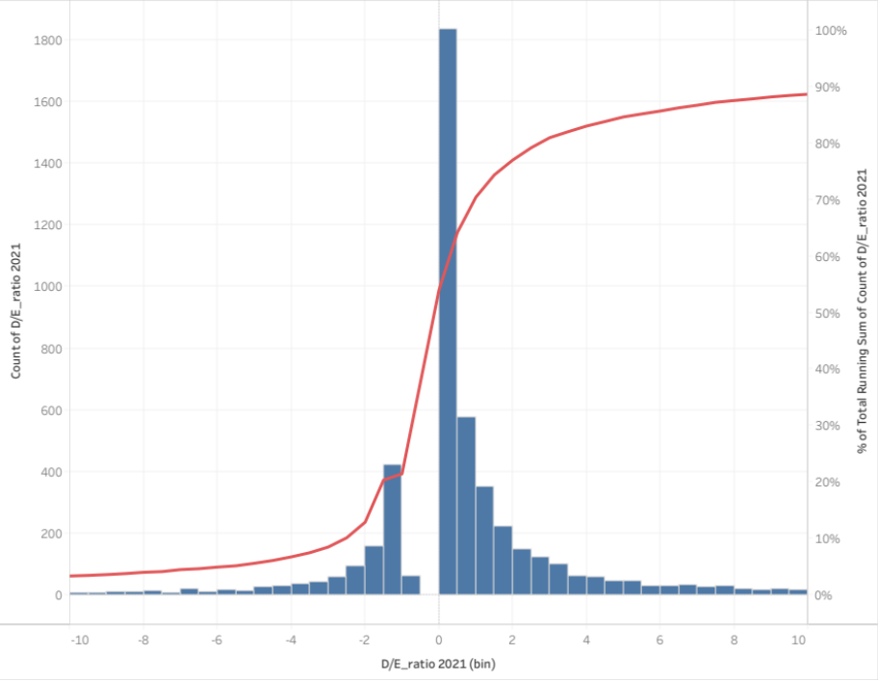
From the histogram, almost 50% of companies have a current ratio of less than 1. Indicating the incapability of meeting it’s short term financial obligations whilst around 25% of companies have a current ratio greater than or equal to 3, showing that these companies are not utilising the most out of their assets. Generally, there are financial concerns within this sector in the short term.
Around 20% of companies have a debt to equity ratio which is negative implying liabilities exceed their assets. These companies are seen as high-risk companies to invest in and there is a potential of bankruptcy.
However, with around 60% of companies having a debt/equity ratio between 0-2, the human health services is overall a risk averse sector.

Current Ratio= Current assets/current liabilities
Debt/equity ratio = Total liabilities/ Total equity

